

**ASSESSMENT FORM**

**Course:** **COMP6047001 - Algorithm and Programming**

**Method of Assessment:** **Case Study**

**Semester/Academic Year : 1/2023-2024**

**Name of Lecturer : Gredion Prajena, S.Kom., M.T.I.**

**Date : 20 December 2023**

**Class : LE01**

**Topic : Material Review II**

|  |  |
| --- | --- |
| **Group Members :** | 1. Justin Cahyo |

**Student Outcomes:**

**(SO 2) Mampu merancang solusi aplikasi piranti lunak berdasarkan analisis permasalahan yang dapat diselesaikan dengan pendekatan terstruktur dalam bidang informatika;**

***Able to design software application solutions based on problems analysis which can be solved with structured approach in informatics area*;**

**Learning Objectives:**

**(LObj 2.2) Mampu mengimplementasikan solusi berbasis komputasi untuk memenuhi serangkaian persyaratan komputasi tertentu dalam konteks ilmu komputer**

***Able to implement a computing-based solution to meet a given set of computing requirements in the context of computer science.***

**Learning Outcomes:**

**LO-2 : apply syntax and functions in C language in problem solving**

**LO-3 : construct a program using C language in problem solving**

| **No** | **Related LO – Lobj - SO** | **Assessment criteria** | **Weight** | **Excellent (85 - 100)** | **Good (75-84)** | **Average (65-74)** | **Poor (0 - 64)** | **Score** | **(Score x Weight)** |
| --- | --- | --- | --- | --- | --- | --- | --- | --- | --- |
| 1 | LO 2 – LObj 2.2 – SO 2 | Ability to apply C syntax for problem solving | **50%** | 85% - 100% of C syntax is correctly applied | 75% - 84% of C syntax is correctly applied | 65% - 74% of C syntax is correctly applied | 0% - 64% of C syntax is correctly applied |  |  |
| 2 | LO 3 – LObj 2.2 – SO 2 | Ability to construct the algorithm into C program | **50%** | The C program is built 85% - 100% correctly | The C program is built 75% - 84% correctly | The C program is built 65-74% correctly | The C program is built 0-64% correctly |  |  | |
|  | **Total Score:** ∑(Score x Weight) | | | | | | | |  | |

Remarks:

**ASSESSMENT METHOD**

Instructions

1. This case study is individual, with duration of 1 week.
2. This case study consists of 2 questions.
3. The first question is a single case study problem, while the second question is a narrative case study to **create 4 functions** with their respective goals. Your program should run correctly to get full score.
4. The second question should be combined into a single .c file. Give comments to explain which function does what.
5. All answers should be included into a single .zip file and submitted to Binusmaya.
6. Example only serves as an example. You may create the command line program as creative as you can.

**Note for Lecturers**:

1. This case study assignment will be held with duration of 1 week in review topic, or week 13.
2. The answer is manually checked by each lecturer (not by system).
3. The example only serves as an example to help students understand the assignment. As long as the function works as intended and the program run correctly, you may give the full score for each problem.
4. Case study 1 **(LO 2 – L.Obj 2.2 – SO 2, 30%)**:

Using string manipulation, iteration, and selection, create a C program to handle string conversion. The string conversion accept a string input with constraint:

$$1≤\left|S\right|≤100$$

$$s ∈S$$

$$s=\{UpperCaseCharacters ∪ LowerCaseCharacters\}$$

The conversion needed **is string reversal, followed by inverse capitalize character at each position**. Inverse capitalize means that lowercase will convert to uppercase, and uppercase will convert to lowercase. Example: if given string **SuniBVerse,** the string will reverse to **esreVBinuS**. After inversion, the program will convert each character with the rules above. Therefore, the final string will become: **ESREvbINUs**.

1. Case study 2 **(LO 3 – L.Obj 2.2 – SO 2, 70%)** :

Download the file from link here: [**https://1drv.ms/u/s!AhuAx03LAKWtnOM9O1wlXSAR84Z67g?e=lVmH5x**](https://1drv.ms/u/s!AhuAx03LAKWtnOM9O1wlXSAR84Z67g?e=lVmH5x)

The file itself is a .csv file containing multiple rows and columns of data. Your task is to build several functions as utility for the data itself, **therefore you should implement function to read the .csv file into your program first.** The functions needed as follows:

* 1. Display (15%)

This function needs 1 variable: **number of rows to be displayed.** This function will display data with $n$ rows**. $n$ must be a positive integer number.** If $n$ > total number of rows, display all data. Example: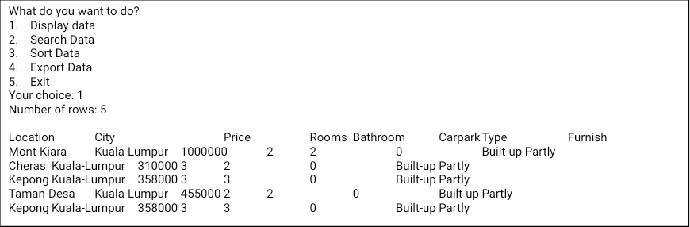

* 1. SelectRow (20%)

This function needs 2 variables as input: **column** and **query value**. This function will display rows that have the **exact value** with the query. If data is not found, print **Not Found**. If data is found, print data details as depicted in example below. If multiple data exist, display all data that matched the query. Example: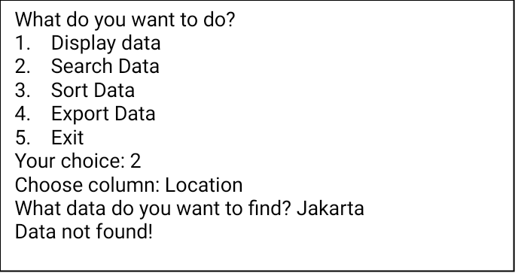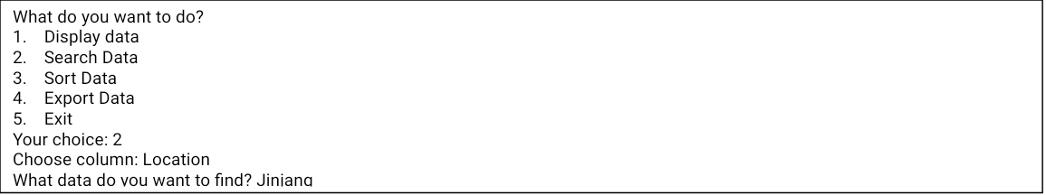

* 1. SortBy (20%)

This function needs 2 variables as input: **column** and **ascending** **or** **descending**. After data was sorted, display the first 10 data. Example (this example only showed 5 data to simplify):

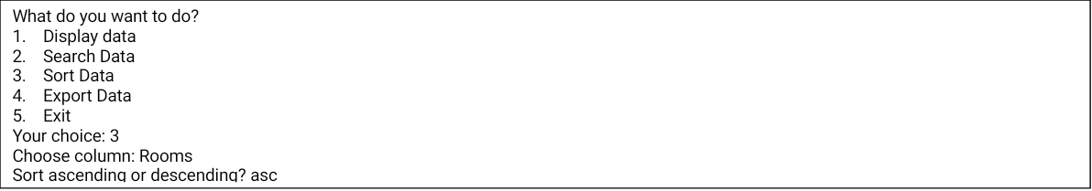

* 1. Export (15%)

This function needs 1 variable as input: **filename (string)**. This function will **write the data into a .csv file or comma separated value** (,) **with user specified filename in the same directory as your program**. Example:

